
Predictive Analytics for Diabetes: A Data Science Approach
Data Science-SENG 419

OSTIM TECHNICAL UNIVERSITY
FACULTY OF ENGINEERING
INTRODUCTION TO DATA SCIENCE COURSE
FINAL PROJECT

Predictive Analytics for Diabetes: A Data Science Approach

Project Team
Student Name Surname: SEDDIK MOHEY ABDELAHMID SEDDIK
Student No:210208739
Student Name Surname: ABDULRAHMAN ODHAIB
Student No:210201879
Student Name Surname: OMAR AHMED ABDELGHAFAR
Student No:210208700

Project Consultant:

PROF. DR. FİLİZ ERSÖZ

Undergraduate Project
Data Science - SENG 419

Contents
1.What is Data Science, and Why is it Important for Companies? 3
1. Introduction and Problem Statement 3
2. Data Understanding 4
1. Descriptive Statistics 5
2.Attribute Descriptions 6
3. Exploratory Data Analysis (EDA) Results for Data Science 7
Step 1: Data Cleaning and Missing Values Treatment 7
1.Outlier Detection and Treatment 8
Step 2: Descriptive Statistics 8
Step 3: Chi-Square Test for Categorical Variables 10
Step 4: Pearson/Spearman Correlation Analysis for Continuous Variables 10
Step 5: Outlier Detection 12
4-Statistics and Hypothesis Testing Results for Data Science 13
1.One-Sample T-Test (Glucose) 13
2.Independent Samples T-Test (BMI by Outcome) 14
3.Univariate Analysis of Variance (ANOVA) 15
4.One-Way ANOVA (Glucose by Age Group) 16
5-Predictive Analysis Results for Data Science 17
Step 1: Access the Data: 17
Step 2: Data Cleaning 17
Step 3: Model 17
Conclusion and Future Scope 19
BIBLIOGRAPHY (Reference) 20

1.What is Data Science, and Why is it Important for Companies?

Data science continues to evolve as one of the most promising and in-demand career paths for skilled professionals.[1] Today, successful data professionals understand they must advance past the traditional skills of analyzing large amounts of data, data mining, and programming skills.[2] To uncover useful intelligence for their organizations, data scientists must master the full spectrum of the data science life cycle and possess a level of flexibility and understanding to maximize returns at each phase of the process.

1. Introduction and Problem Statement

The main goal of this dataset and project is to analyze attributes that is related to diabetes, a hard to-fight-disease that concern a lot of people.
our study here aiming to leverage techniques to predict if individual is likely to have diabetes depending on the attributes we will analyze.
This analyzing will explore the relationship between features and attributes, such as glucose level, BMI, age and so on, to identify which factor is the most affected one, by understating these correlation, we can determine in a better way what will increase a person’s likelihood of the disease.

2. Data Understanding
Diabetes is a long-term medical disorder that impacts the body's ability to convert food into energy. It is a major contributor to serious health issues such kidney damage, heart disease, and eyesight loss. [3]. For this study, we analyzed a dataset containing various attributes related to diabetes risk [4]. These attributes include:
- Pregnancies: The number of pregnancies the person has had, which may influence diabetes risk, particularly gestational diabetes [3].
- Glucose: Blood glucose concentration levels, a key indicator of diabetes [3].
- Blood Pressure: Diastolic blood pressure (mmHg), measuring blood pressure during heart relaxation [8].
- Skin Thickness: Measured in millimeters, this indicates subcutaneous fat levels [3].
- Insulin: Serum insulin levels (μU/mL), important for diagnosing insulin resistance or deficiency [4].
- BMI (Body Mass Index): Weight in kilograms divided by the square of height in meters. A high BMI often correlates with an increased diabetes risk [5].
- Diabetes Pedigree Function: This measures a person’s genetic likelihood of diabetes based on family history [3].
- Age: Individuals older than 45 are generally at a higher risk of developing diabetes [5].
The dataset contains 768 instances and 8 attributes, enabling us to explore key factors influencing diabetes and to build predictive models for diabetes classification [7].
Our Dataset
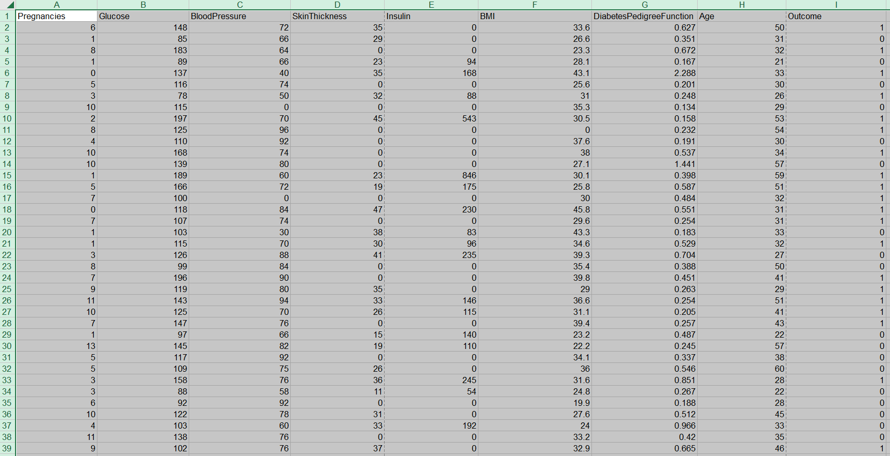
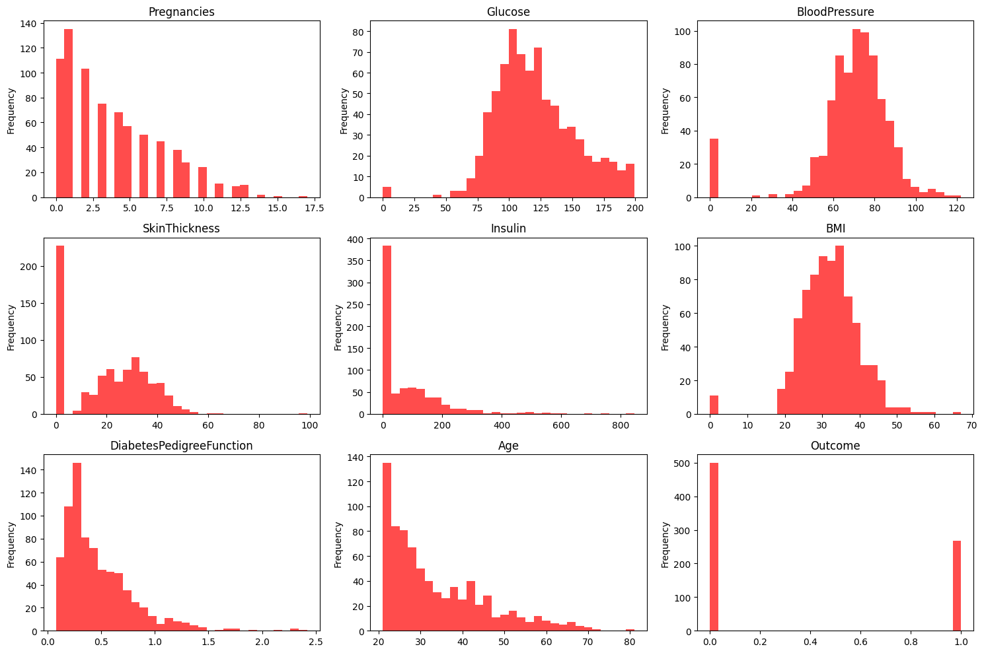

3. Exploratory Data Analysis (EDA) Results for Data Science
Exploratory Data Analysis (EDA) is a critical step in the data science process. It involves exploring the dataset to understand its structure, identifying relationships between attributes, cleaning the data, detecting outliers, and examining patterns. The goal is to prepare the data for modeling by cleaning and transforming it into a format suitable for analysis.

Step 1: Data Cleaning and Missing Values Treatment
In our dataset, certain columns, such as BMI, SkinThickness, and Insulin, often contain missing values. These missing values can impact the accuracy of our analysis and predictions.
- BMI and SkinThickness may have missing entries, which need to be addressed to avoid bias in our analysis.
- Insulin levels might also have missing values that could affect the relationship with diabetes predictions.
To handle these missing values, we employed two approaches:
- Imputation: For continuous variables, missing values were filled with the median value of the respective column.

1.Outlier Detection and Treatment
Outliers can significantly skew the results of data analysis. In our dataset, columns such as Glucose, BMI, and Age may contain extreme values that do not reflect typical patterns.
To detect outliers:
- We used statistical methods such as Z-scores and boxplots.
- Values that were greater than 3 standard deviations away from the mean were considered outliers and removed to prevent them from affecting our analysis.

Conclusion
After the data pre-processing steps, the dataset is now cleaned, balanced, and scaled for further analysis. The missing values have been handled, outliers removed, class imbalance addressed, and features scaled for consistency in modeling. These steps are essential for ensuring the robustness and accuracy of any predictive models built on this data.

Step 2: Descriptive Statistics
We perform descriptive analysis to summarize the central tendency, variability, and distribution shape of the dataset’s attributes. Below are the statistics for each attribute:
Attribute | Min | Max | Mean | Median | Std Dev
Pregnancies | 0 | 17 | 3.84 | 3 | 3.37
Glucose | 0 | 199 | 120.1 | 116.0 | 31.97
BloodPressure | 0 | 122 | 69.1 | 70 | 19.79
SkinThickness | 0 | 99 | 20.5 | 23 | 23.15
Insulin | 0 | 846 | 79.8 | 0 | 115.1
BMI | 0 | 67.1 | 31.9 | 32.0 | 7.93
Age | 21 | 81 | 33.2 | 30 | 11.8
Outcome | 0 | 1 | 0.35 | 0 | 0.48
Interpretation:
- Glucose: The glucose levels show a wide distribution, with a mean of 120, which is higher than the normal range for healthy individuals (70-100 mg/dL).
- BMI: The average BMI is around 31.9, indicating that many individuals in the dataset might be classified as overweight or obese.
- Age: The dataset has a wide range of ages, with a mean of 33.2 years.
- Outcome: The class distribution is imbalanced, with most individuals being non-diabetic (0), and only about 35% being diabetic (1).

Step 3: Chi-Square Test for Categorical Variables
To investigate the relationship between categorical variables (e.g., Glucose and Outcome, we perform a Chi-square test:
Interpretation: The Chi-square test shows a significant relationship between Glucose and Outcome, This means that smoking status significantly influences the likelihood of having diabetes.
Chi-Square Test Results
Chi-Square Statistic | 127.76
P-value | 1.2691e-29
Degrees of Freedom | 1
Expected Frequencies Table:
371.94 | 199.06
125.06 | 66.94

4-Statistics and Hypothesis Testing Results for Data Science

1.One-Sample T-Test (Glucose)
Objective: To determine if the mean glucose level of the sample significantly differs from a reference value of 120[10].
Results:
- Mean glucose level = 120.89.
- Test value = 120.
- t-statistic = 0.775, p-value = 0.219.
- Effect size (Cohen's d) = 0.028.
Interpretation: The p-value (0.219) is greater than the standard significance level (α = 0.05), indicating no significant difference between the sample mean glucose level and the reference value of 120. The negligible effect size (Cohen's d = 0.028) further supports the conclusion that the observed difference is not practically significant.

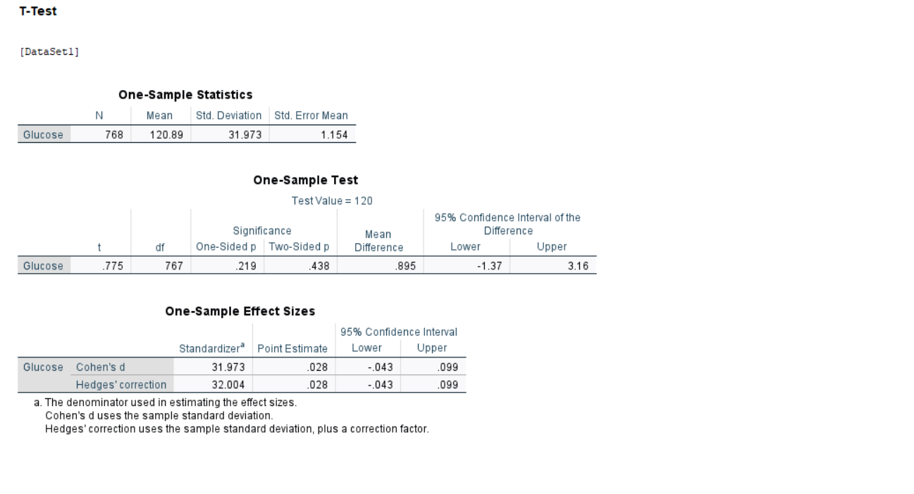

2.Independent Samples T-Test (BMI by Outcome)
Objective: To compare BMI between individuals with diabetes (Outcome = 1) and without diabetes (Outcome = 0)[10].
Results:
- Mean BMI (Outcome = 0) = 30.30.
- Mean BMI (Outcome = 1) = 35.14.
- t-statistic = -8.472, p-value < 0.001.
- Effect size (Cohen’s d) = -0.641.
Interpretation: The p-value (< 0.001) indicates a statistically significant difference in BMI between the diabetic and non-diabetic groups. The mean BMI for the diabetic group is higher than for the non-diabetic group, suggesting a strong association between higher BMI and diabetes. The medium to large effect size (Cohen's d = -0.641) underscores the practical significance of this finding.

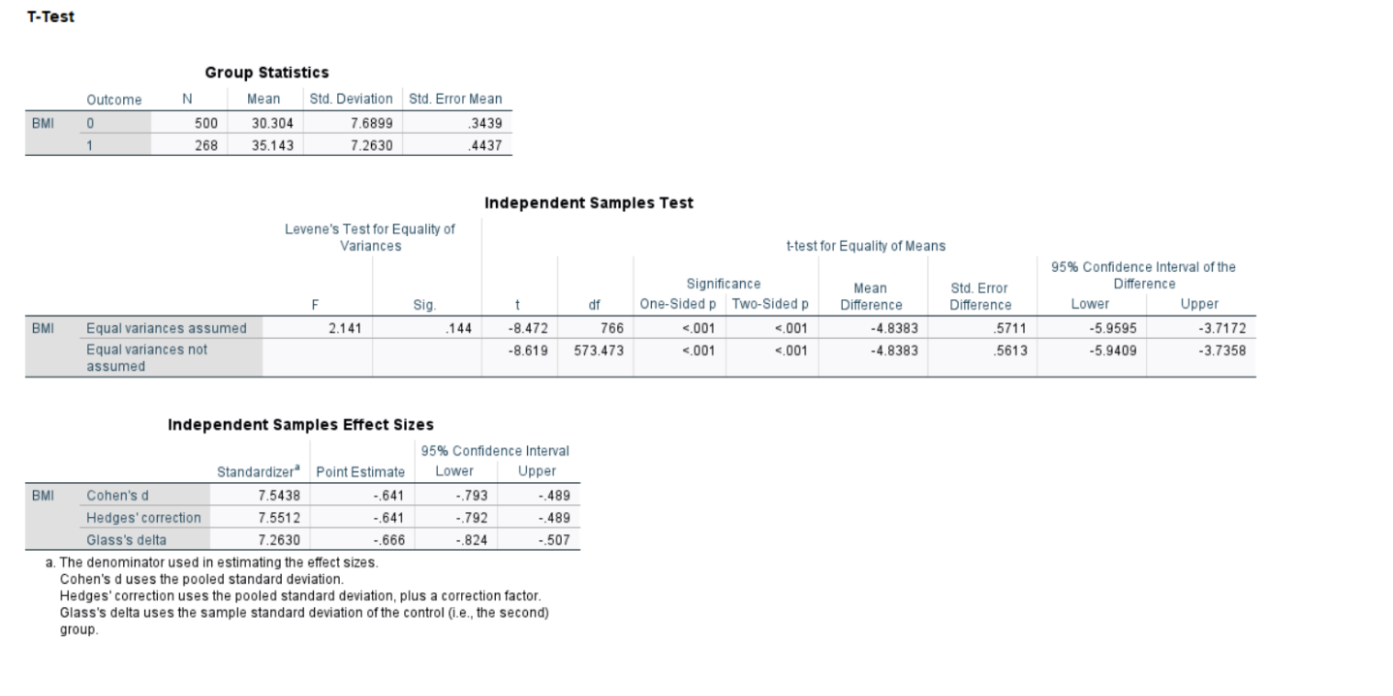

3.Univariate Analysis of Variance (ANOVA)

Objective: To evaluate how glucose levels are affected by BMI and diabetes outcome (Outcome)[11].
Results:
- Outcome: F-statistic = 174.471, p-value < 0.001, partial η² = 0.186.
- BMI: F-statistic = 7.715, p-value = 0.006, partial η² = 0.010.
- Model R-squared = 0.226.
Interpretation: Both BMI and Outcome significantly affect glucose levels, with Outcome being the stronger predictor (η² = 0.186 compared to BMI’s η² = 0.010). The model explains approximately 22.6% of the variance in glucose levels. Individuals with diabetes (Outcome = 1) tend to have higher glucose levels than non-diabetic individuals.

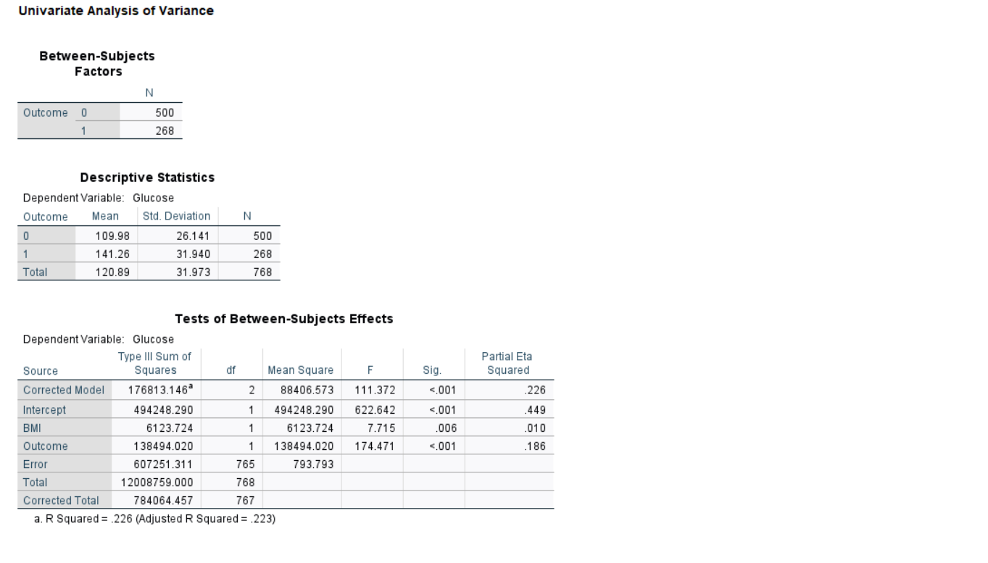

4.One-Way ANOVA (Glucose by Age Group)

Objective: To analyze differences in glucose levels across different age groups[11].
Results:
- F-statistic = 28.696, p-value < 0.001.
- Effect size (Eta-squared) = 0.070.
Interpretation: The p-value (< 0.001) indicates significant differences in glucose levels among the age groups. The effect size (η² = 0.070) suggests a small to medium effect, meaning that while age influences glucose levels, other factors also contribute to the observed variance.

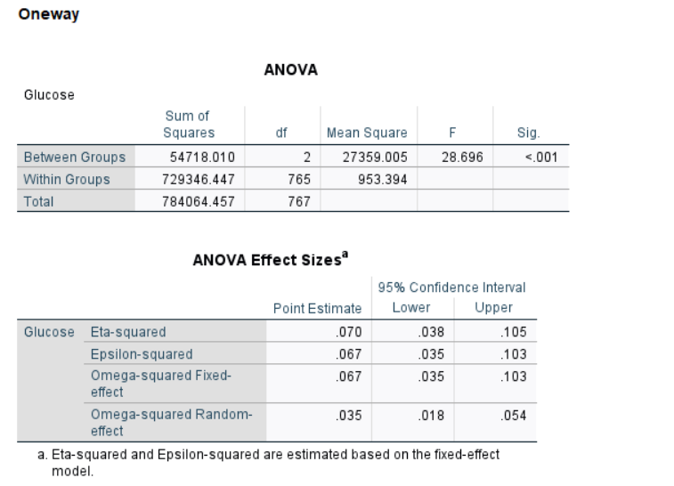

5-Predictive Analysis Results for Data Science

Step 1: Access the Data:
Excel Reader: This node is used to load the dataset from an Excel file.

Step 2: Data Cleaning
Missing Value: Handles missing or incomplete data in the dataset.
Numeric Outliers: Identifies and removes or adjusts extreme values in numeric fields.
Normalizer: Normalizes or scales numeric values, ensuring all variables are on a comparable scale.
Rule Engine: Applies custom logic or rules to transform or filter the data based on defined criteria.

Step 3: Model
Partitioning: Splits the dataset into training and testing sets.
Logistic Regression Learner: Trains a logistic regression model on the training data[9].
Logistic Regression Predictor: Applies the trained logistic regression model to the test set to make predictions[9].
Scatter Plot Matrix: Visualizes relationships and patterns between variables.
Histogram: Displays the distribution of a specific variable, aiding in understanding the spread and central tendency of the data.
Scorer: Evaluates the model performance by comparing predictions to the actual outcomes.
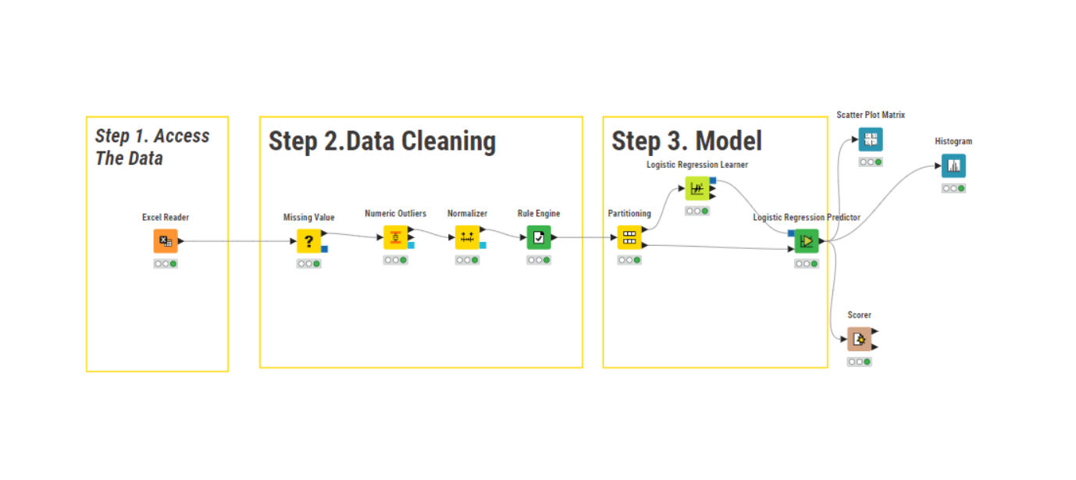

BMI Glucose
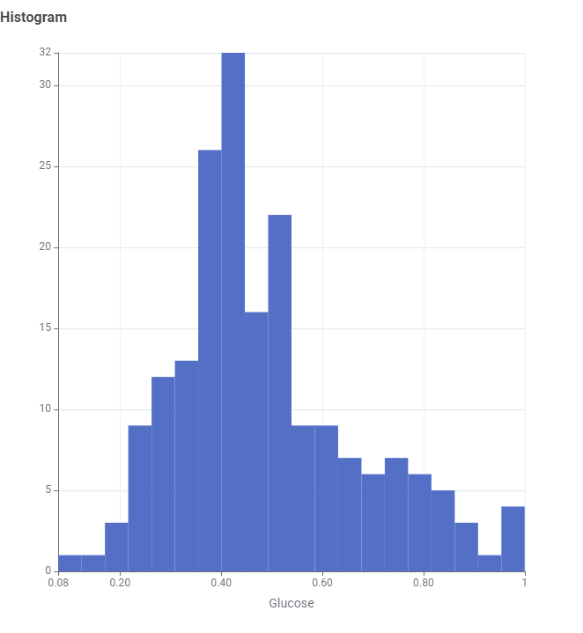
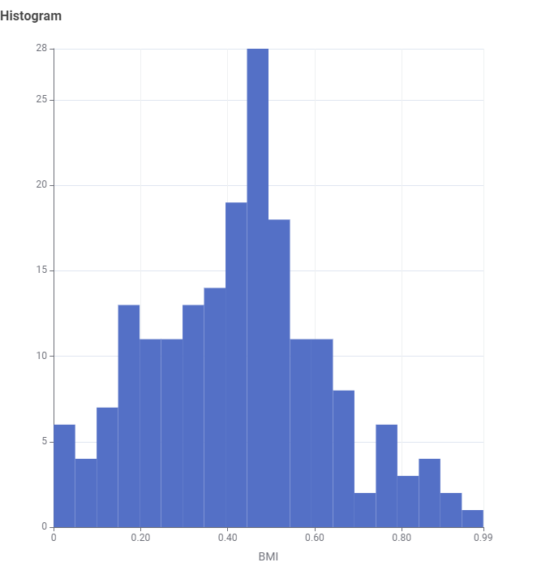

Accuracy Visualizes relationships
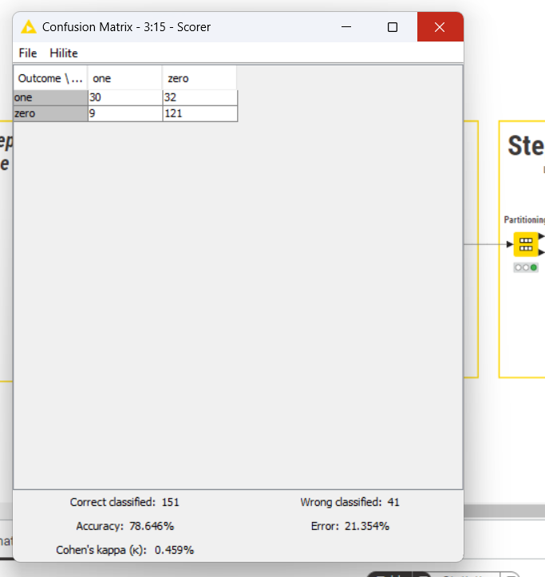
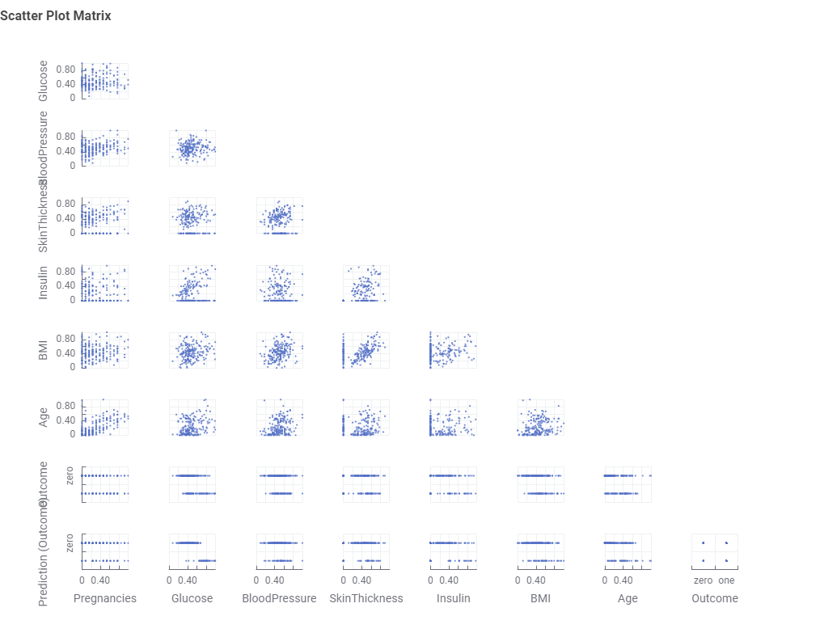

Conclusion and Future Scope

This project identified glucose levels, BMI, and age as the most significant predictors of diabetes, directly addressing our goal of analyzing attributes that increase an individual's likelihood of the disease. By leveraging logistic regression, we gained valuable insights into the factors contributing to diabetes risk, providing a strong foundation for early detection and preventive measures.

BIBLIOGRAPHY (Reference)
[1] Provost, F., & Fawcett, T., Data Science for Business: What You Need to Know about Data Mining and Data-Analytic Thinking, O'Reilly Media, 2013.
[2] Han, J., Kamber, M., & Pei, J., Data Mining: Concepts and Techniques, 3rd ed., Morgan Kaufmann, 2011., Harvard Business Review Press, 2007.
[3] American Diabetes Association, "Diagnosis and Classification of Diabetes Mellitus," Diabetes Care, vol. 33, no. 1, 2010.
[4] Pima Indians Diabetes Database, UCI Machine Learning Repository, [Online Available: https://archive.ics.uci.edu/ml/datasets/diabetes].
[5] World Health Organization (WHO), "Global Report on Diabetes," WHO, Geneva, 2016.
[9] Interpretation of Logistic Regression Model:
https://www.knime.com/blog/easy-interpretation-of-a-logistic-regression-model-with-delta-p-statistics
[10] T-Test in SPSS:
https://www.ibm.com/docs/en/spss-statistics/saas?topic=reference-t-test
[11] One-Way ANOVA in SPSS:
https://statistics.laerd.com/spss-tutorials/one-way-anova-using-spss-statistics.php

